  - Customer Segmentation

Jahnavi Bollimuntha
16325267
jbbcw@umsystem.edu
Shivani Nagamandla
16354867 snhcf@umsystem.edu
Viswanth Tammana
16352538
vtgkc@unsystem.edu
Dharani Thakkallapally
16354872
dtt4q@umsystem.edu

Introduction
Customer segmentation is key to business intelligence, helping businesses better target their products and marketing. Using a dataset with information on mall customers' behavior, including spending patterns and demographics like gender, age, and annual income, we aim to create distinct customer segments using unsupervised methods. By analyzing this data, we can uncover hidden trends and group customers with similar traits, enabling personalized marketing strategies and a deeper understanding of customer needs. To create distinct customer segments, we applied four clustering methods: K-Means, Hierarchical clustering, Gaussian Mixture Models (GMM), and Fuzzy C-Means clustering. These approaches allowed us to explore different ways to group data and determine the optimal segmentation. We assessed the performance of each algorithm using the silhouette score, which measures cluster quality based on cohesion and separation.

Related Work
In the field of customer segmentation, clustering methods play a crucial role in identifying distinct customer groups to inform business strategies and marketing efforts. Traditional approaches like K-Means are widely used due to their simplicity and efficiency, creating clusters based on distance from centroids. However, these methods often assume spherical clusters and may be sensitive to the initial choice of centroids. Hierarchical clustering offers a different approach by building a tree-like structure, allowing for more nuanced exploration of data relationships, but it can be computationally expensive for large datasets.

Recent advances in clustering techniques have introduced greater flexibility and adaptability. Gaussian Mixture Models (GMM) provide a probabilistic approach, allowing data points to belong to multiple clusters with varying probabilities. This method is well-suited to complex, overlapping clusters. Fuzzy c-means also adopts a softer clustering approach, permitting partial membership across clusters, which can be useful in scenarios where customer behavior isn't strictly categorical.

These state-of-the-art methods offer a diverse toolkit for customer segmentation, each with unique strengths and trade-offs. Our project explores these four clustering methods—K-Means, hierarchical clustering, GMM, and fuzzy c-means—to determine the most effective approach for segmenting customers based on spending patterns and demographics. By evaluating these methods, we aim to uncover hidden customer segments and provide actionable insights for business intelligence.

2 Exploratory Data Analysis
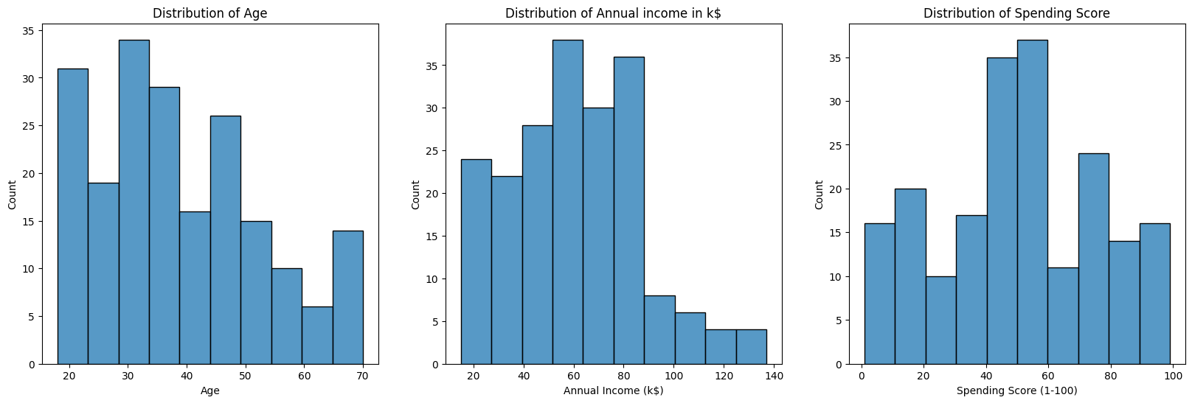
Figure 2.1 Distribution of Age, Annual Income, and Spending score

In Figure 2.1, shows histograms illustrating the distribution of age, annual income, and spending score among mall customers. Most visitors are in their 20s and 30s. The largest group of customers earns between $60k and $80k annually. The highest spending scores are between 55 and 60 out of 100.

From Figure 2.2, we can observe that annual income and spending score has a positive correlation.

In Figure 2.3, the plot illustrates that we can segment clusters clearly into 5 groups using features Annual income and spending score.
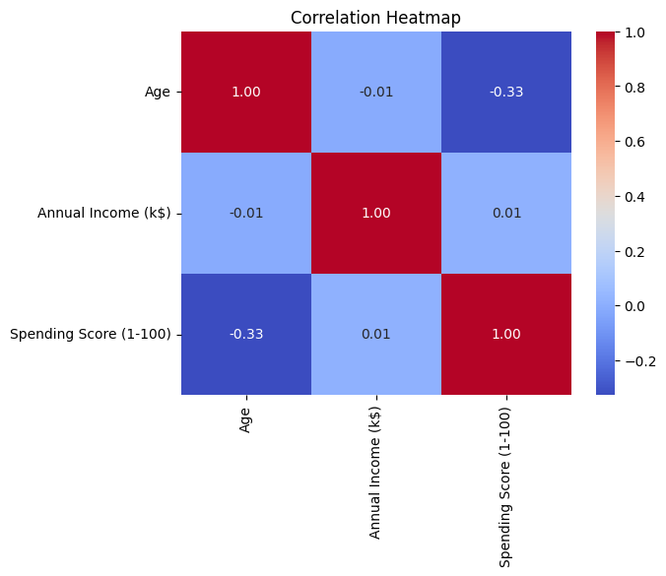
Figure 2.2 Correlation Heatmap

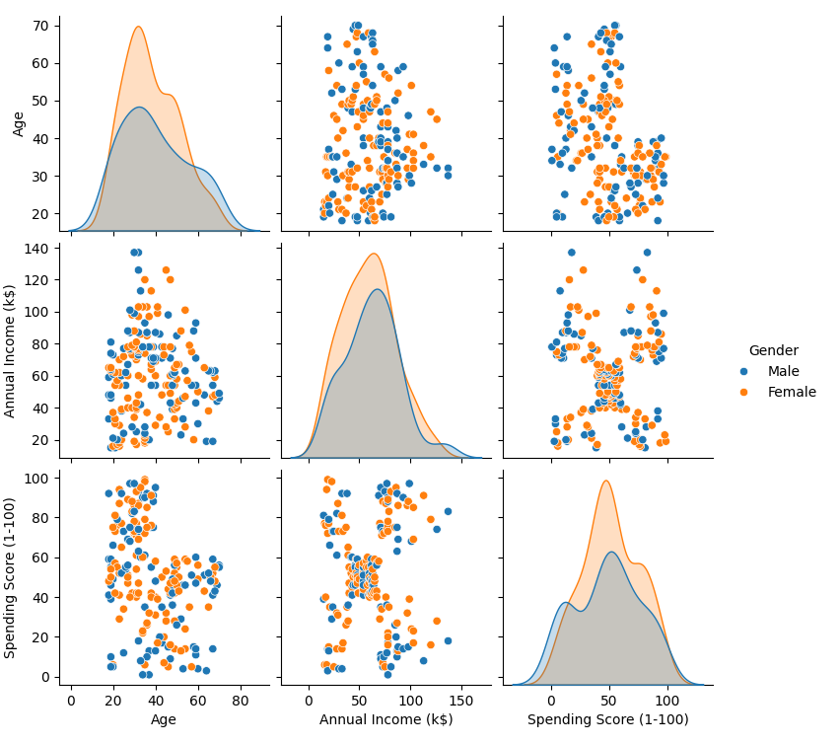
Figure 2.3 Pair plot of Age, Annual income, and Spending score.

3 Model Development
K-means Clustering
To determine the optimal number of clusters for our dataset, we applied the Elbow method. In Figure 3.1, the distortion score shows a noticeable "elbow" at k = 5, indicating that the rate of improvement in clustering quality decreases after this point. suggesting that k = 5 is a suitable choice for the optimal number of clusters.

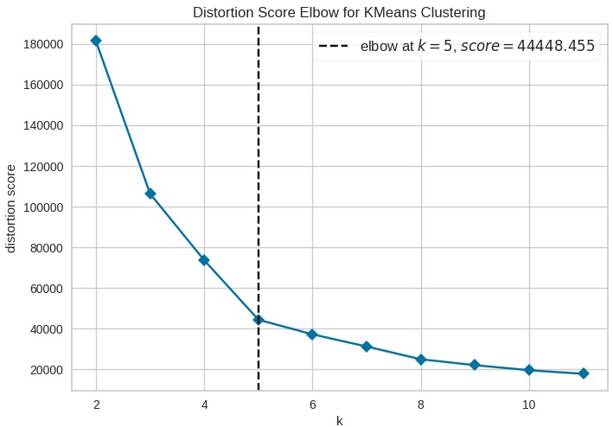
Figure 3.1 Elbow method to find optimal K value.

With k = 5, we applied the K-Means algorithm to our dataset to segment into 5 clusters. The process began with the initialization of centroids, using the k-means++ method, which selects initial centroids strategically to minimize convergence issues. Next, data points are assigned to the nearest centroid using Euclidean distance. The centroids were then updated by recalculating the mean (average) of all points within cluster. This assignment and update process was repeated until the centroids stabilize or the maximum number of iterations was reached. To ensure reproducibility, we set a random state of 42, which ensures consistent initial centroid selection and allows the same results across multiple runs. Figure 3.1. illustrates the results of our K-Means clustering, showing the 5 optimal clusters.

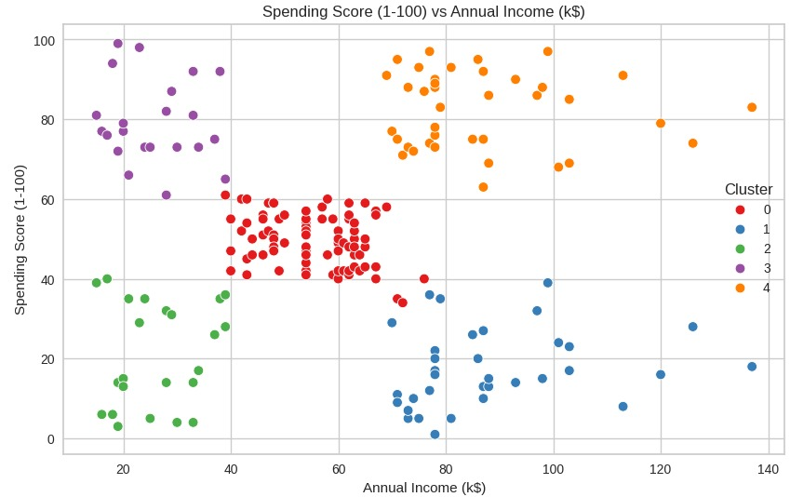
Figure 3.2 Customer Segmentation using K-means.
Hierarchical Clustering
By repeatedly merging the closest pairs of clusters until all data points are a part of a single, sizable cluster, a technique known as agglomerative hierarchical clustering can be used to group comparable data points into clusters. Through the creation of a hierarchical structure of nested clusters, relationships between data points at different levels of granularity can be explored.

Focused on annual income and spending score by utilizing agglomerative hierarchical clustering on a dataset that represents customer information. To visualize the hierarchical clustering process, a dendrogram is first made. There is a reference line given in case the number of clusters has to be determined. The data is then subjected to the scikit-learn Agglomerative Clustering method, which generates cluster labels for every data point. With the use of these labels, a scatter plot is created, with each point colored in accordance with the cluster to which it belongs. This makes it easier to identify different clusters based on spending and income patterns. To evaluate the quality of the clustering, the silhouette score is finally calculated, which gives an indication of how well-separated the clusters are.
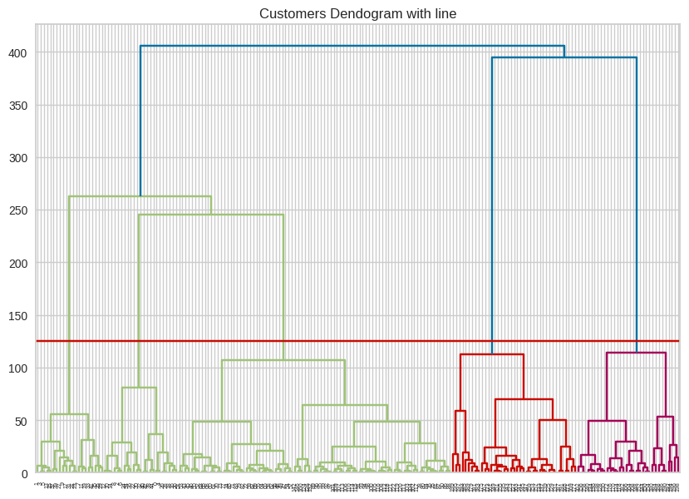
Figure 3.3 Dendrogram.
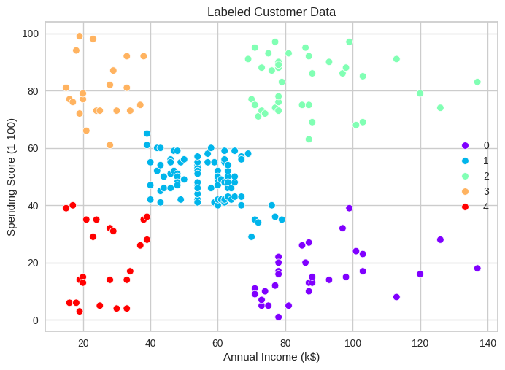
Figure 3.4 Customer segmentation using hierarchical clustering.
Gaussian Mixture Model
A Gaussian mixture model (GMM) is a probabilistic model that assumes data points are derived from a finite number of Gaussian distributions, each with its own mean and covariance. We used the built-in GMM function in Scikit Learn to fit the mall customers dataset based on their annual income and spending score. The resulting clusters are visualized as a scatter plot, with each point representing a customer. The points are color-coded according to their cluster label. This visualization helps to understand how customers are classified based on their spending habits and income levels.
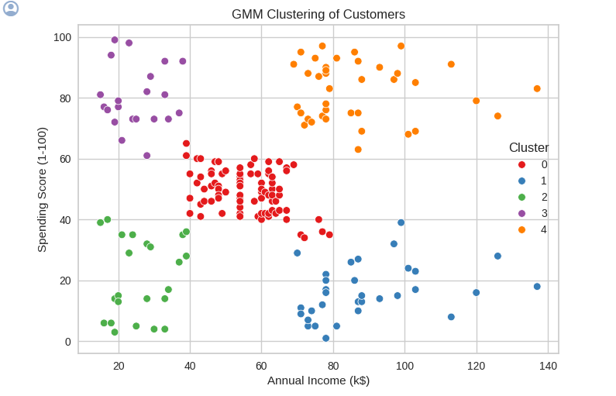
Figure 3.5 Customer segmentation using GMM.

Fuzzy C-Means
Fuzzy c-means (FCM) is a clustering technique that allows data points to belong to multiple clusters with varying degrees of membership, unlike traditional clustering methods where each data point is assigned to a single cluster. In our analysis, we applied FCM to our dataset to explore this flexible approach to clustering.
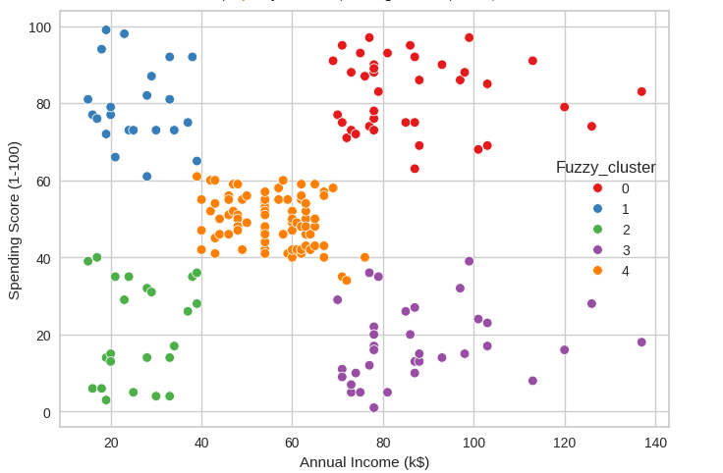
Figure 3.6 Customer segmentation using FCM.
4 Results and discussion
Cluster 0: This cluster includes customers with moderate annual incomes ranging from $39,000 to $80,000, as well as moderate spending scores between 35 and 65. It has the maximum number of customers.
Cluster 1: Customers in this cluster have higher annual incomes ranging from $68,000 to $137,000 but lower spending scores, which typically range from 1 to 40.
Cluster 2: This cluster is made up of customers with lower annual incomes ranging from $10,000 to $40,000, as well as lower spending scores of 2 to 41. It has a minimum number of customers.
Cluster 3: Customers in this cluster have lower to moderate annual incomes ranging from $10,000 to $39,000 but higher spending scores ranging from 60 to 100%.
Cluster 4: Customers in this cluster, like Cluster 1, have higher annual incomes ranging from $68,000 to $137,000, but they also have higher spending scores, ranging from 62 to 98.
These summaries provide insights into the various segments of mall customers based on their income levels and spending habits, which can be used to develop targeted marketing strategies and personalized services.
Performance evaluation
In Table 1, We have calculated silhouette scores for all four algorithms. Almost all the algorithms performed the same with slight differences.
Table 1
K-Means | Hierarchical | Gaussian Mixture | FCM
0.55393199744464 | 0.5529945955148897 | 0.55282437048956 | 0.5539319974446
Conclusion
Using customer segmentation insights can greatly improve marketing strategies. For example, Cluster 0, with moderate incomes and spending scores, might respond well to value-focused promotions. Cluster 1, with higher incomes but lower spending scores, could be encouraged to spend more through targeted incentives. For Cluster 3, whose members are willing to spend despite lower incomes, campaigns emphasizing premium experiences could be effective.

By customizing marketing efforts based on each cluster's characteristics, businesses can boost customer engagement and sales. This tailored approach aligns marketing with customer preferences, leading to more effective campaigns and increased revenue.

Future Work
In future work, we aim to explore several directions to enhance our understanding of customer segmentation and its applications in business intelligence. One direction is investigating advanced clustering methods, like deep learning-based algorithms, which can capture complex patterns in high-dimensional data. We also plan to expand the range of features used in clustering. Adding variables such as purchase history, customer satisfaction, or social media engagement could provide deeper insights into customer behavior, leading to more personalized marketing strategies. Another objective is to assess the stability and generalizability of our clustering models across different datasets and industries. Testing our methods in varied contexts will help validate their effectiveness and adaptability.

References

[1] P. Lalwani, M. K. Mishra, J. S. Chadha, and P. Sethi, “Customer churn prediction system: a machine learning approach,” Computing, vol. 104, Feb. 2021, doi: https://doi.org/10.1007/s00607-021-00908-y.

[2] E. Y. L. Nandapala and K. P. N. Jayasena, “The practical approach in Customers segmentation by using the K-Means Algorithm,” 2020 IEEE 15th International Conference on Industrial and Information Systems (ICIIS), Nov. 2020, doi: https://doi.org/10.1109/iciis51140.2020.9342639.
‌
[3] N. Tressa, V Asha, P. Kumar, Om Shree, Uday Kiran M, and S. Reddy, “Customer-Based Market Segmentation Using Clustering in Data mining,” Jan. 2024, doi: https://doi.org/10.1109/idciot59759.2024.10467258.
‌
[4] W. X. Toh, “Customer segmentation on clustering algorithms,” eprints.utar.edu.my, Jan. 01, 2023. http://eprints.utar.edu.my/id/eprint/5523 (accessed May 04, 2024).
‌

